Nanowheels Get Revved Up
(Science Now, 23 December 2002)

The infinitesimal motors that promise to drive the microscopic devices of the future may have a surprising turbo booster: ultraviolet lamps. New findings from an international team of scientists reveal that light can make molecular rotors spin more than a million times faster than before, which researchers say could one day have applications such as winding up pulleys in synthetic muscles.

The cogs in question are molecules known as rotaxanes, in which rings of organic chemicals revolve around linear threads. Because objects at the molecular level stop moving only if they reach absolute zero, such loops require no pushes or pulls to keep them whirling. Controlling such motions is key to creating machinery at this scale.
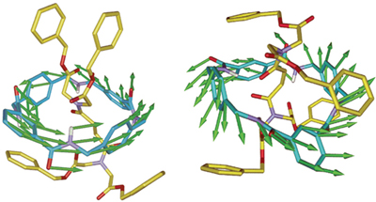
Spin control. Weaker hydrogen bonds enable the ring in the structure on the right to spin up to a million times faster than in the structure on the left.
CREDIT: F. GATTI ET AL./PNAS/EUREKALERT!
Organic chemist David Leigh of the University of Edinburgh, U.K., and colleagues had previously discovered that they could slow the spin of rotaxane rotors 1000-fold with oscillating electric fields, which apparently polarize and strengthen the weak hydrogen bonds holding a ring to its thread. Now, in a paper published online this week in the Proceedings of the National Academy of Sciences, Leigh and his team report that zapping the rotors with UV light makes them spin faster. Using nuclear magnetic resonance (NMR) spectroscopy, the team verified that the light breaks down the hydrogen bonds. The rays do this by causing molecules in the ring known as amide groups to shuffle from opposite sides of the carbon bond to the same side, loosening hydrogen bonds in the process. "Before we had the brake, and now we have the accelerator," Leigh says.
Heating the rotors up could also send them into overdrive, but Leigh says a million-fold boost like the one they triggered with light would require a roughly 100-degree Celsius increase in temperature, "something not always practical." So far, this drastic increase in speed takes about 5 to 10 minutes to trigger with the 150-watt mercury lamp the researchers used, but Leigh says more powerful laser pulses could set off turbo boosts in a microsecond or less. Different wavelengths of light should trigger this effect in different rotaxanes, he adds, allowing scientists to customize the system for different chemical setups.
Using light to affect the spin rate is a clever approach, says organic chemist Harry Gibson of Virginia Polytechnic Institute and State University in Blacksburg. He adds that the group has made "masterful" use of NMR spectroscopy and other techniques to study the underlying mechanism.
--CHARLES CHOI
Related sites
Illustrations of rotaxanes from Harry Gibson's group
Rotaxane picture gallery

